



HDSE-II

 APP- BABY SHOP HUB

* **GROUP MEMBERS NAMES**
  + - MUHAMMAD SHUJA UDDIN ( 1382120 )
    - DUAA IRSHAD ( 1385212 )
    - ALISHA FATIMA ( 1385301 )
    - ZARBANO BAKSH (1421669)
    - MUHAMMAD HASSAM FARHAN ( 1385298 )
* **What is app baby shop hub?**

Baby Shop Hub" is likely a retail platform or online marketplace focused on baby products. It typically offers a range of items such as clothing, toys, accessories, and essentials for infants and toddlers. The term "hub" suggests it might be a central place where various brands and products are available, making it easier for parents to find everything they need for their babies in one spot.

* **Functional Requirements:**

**User Registration and Authentication:**

**User Registration**: Users should be able to create an account with their personal information, including name, email, and password.

**User Authentication**: Secure login and authentication mechanisms to ensure that only registered users can access their accounts.

**User Profile**: Users should have a profile section where they can manage their personal information, delivery addresses, and payment methods.

**Product Browsing and Search:**

**Product Categories:** Display a variety of product categories relevant to infants, such as diapers, baby food, clothing, toys, and more.

**Product Search:** Implement a search feature to enable users to find specific products by name, brand, or category.

**Product Details:** Display detailed product information, including images, descriptions, prices, and customer reviews.

**Shopping Cart and Checkout:**

**Add to Cart:** Allow users to add products to their shopping cart for future purchase.

**Cart Management:** Users should be able to view and manage the contents of their shopping cart, including updating quantities and removing items.

**Checkout Process:** Implement a smooth and secure checkout process, including order review, payment processing (dummy), and order confirmation.

**Order History and Tracking:**

**Order History:** Display a history of previous orders, including order status, items purchased, and order details.

**Order Tracking:** Enable users to track the delivery status of their orders in real-time.

**Reviews and Ratings:**

**Product Reviews:** Allow users to submit and read product reviews and ratings, providing valuable feedback to other users.

**Seller Ratings:** Provide a rating system for sellers to build trust and credibility among users.

* **Admin Panel:**

**Product Management:** An admin panel to manage product listings, prices, and inventory.

**User Management:** Ability to manage user accounts, monitor user activity, and address user inquiries.

**Order Management:** Monitor and manage orders, including tracking and order status updates.

**Feedback and Support:**

**User Support:** A support system for users to contact for assistance, report issues, and provide feedback.

**Non-Functional Requirements:**

**Responsiveness:** The app should respond to user interactions within 1-2 seconds, ensuring a smooth and lag-free experience.

**Loading Time:** The app's initial loading time should be minimized to ensure users can access it quickly.

**User Interface:** The app's user interface should be intuitive, following best design practices for mobile apps to ensure ease of use.

**Accessible:** The application should have clear and legible fonts, user-interface elements, and navigation elements.

**User-friendly:** The application should be easy to navigate with clear menus and other elements and easy to understand.

**Operability:** The application should operate in a reliably efficient manner.

**Error Handling:** Implement robust error handling to provide clear error messages to users and gracefully handle unexpected situations.

**Scalability:** The application architecture and infrastructure should be designed to handle increasing user traffic, data storage, and feature expansions.

**Security:** The application should implement adequate security measures such as authentication. For example, only registered users can access certain features.

**User Documentation:** Provide user guides, FAQs, and tutorials to help users understand and navigate the application.

**Developer Documentation:** Maintain developer documentation to assist in further development and maintenance.

**Video:** Provide video displaying complete working of the application.

* **OUR PROJECT IMAGES**

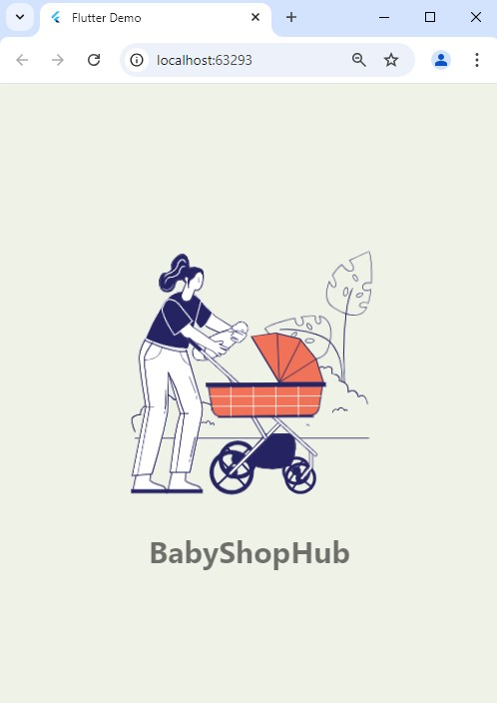**Splash Screen Page:**

**Sign Up Page:**

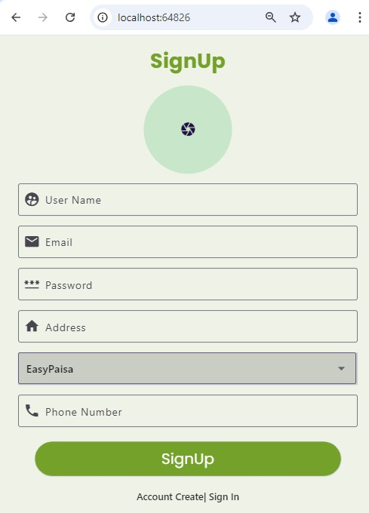

**Login Page:**

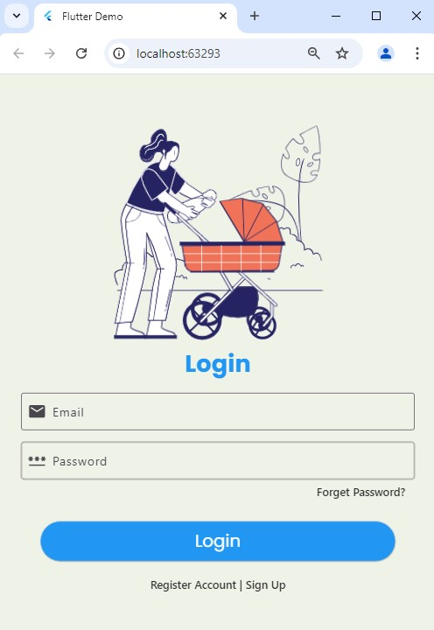

**Forget Password:**

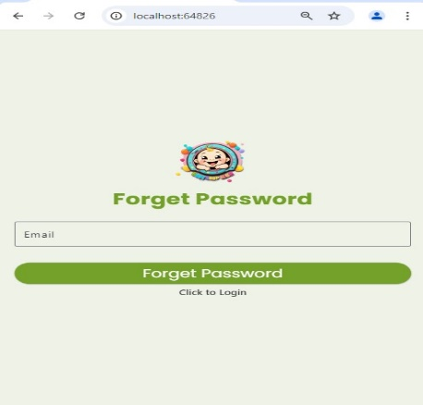

**Invalid Email and Password:**

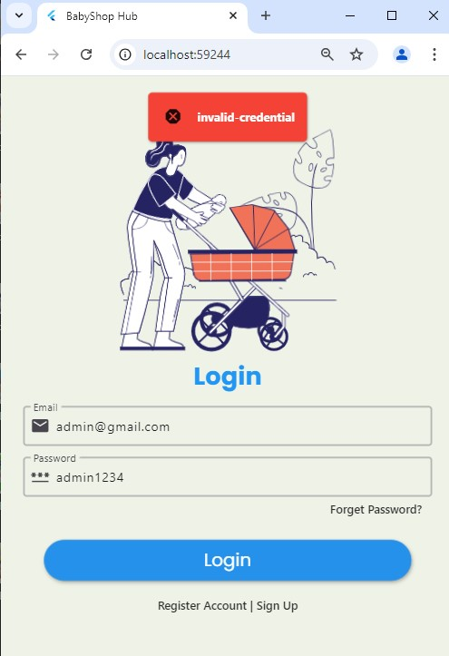

**Home Page:**

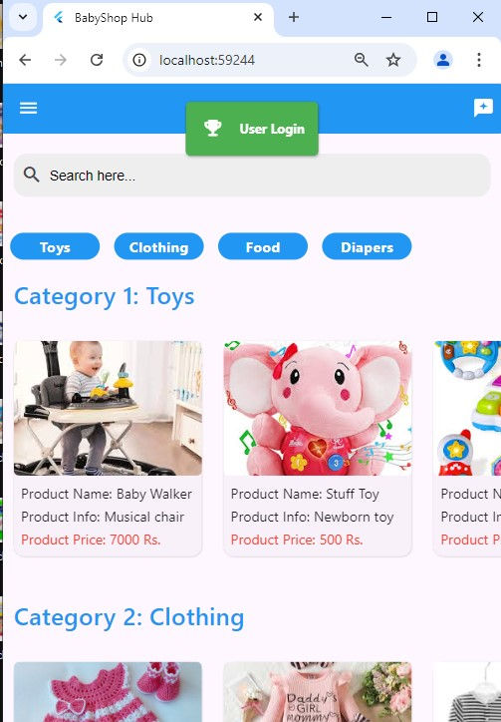

**Review Button:**

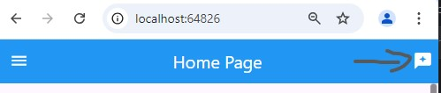

**Searching Products:**

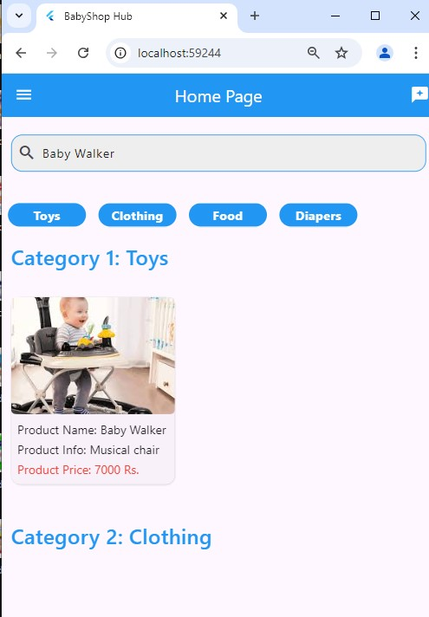

**Categories Searching:**

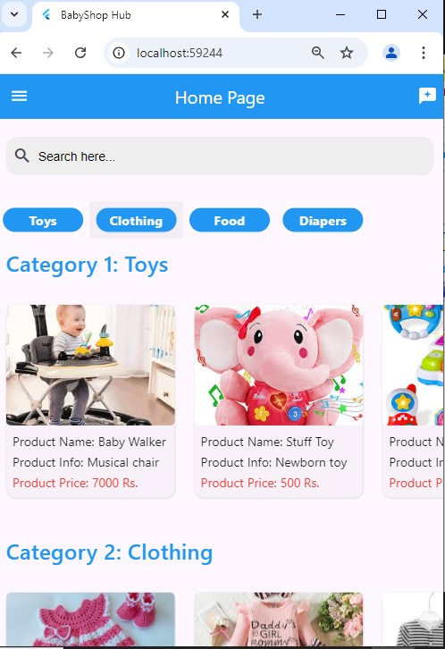

**Rating and Review Products:**

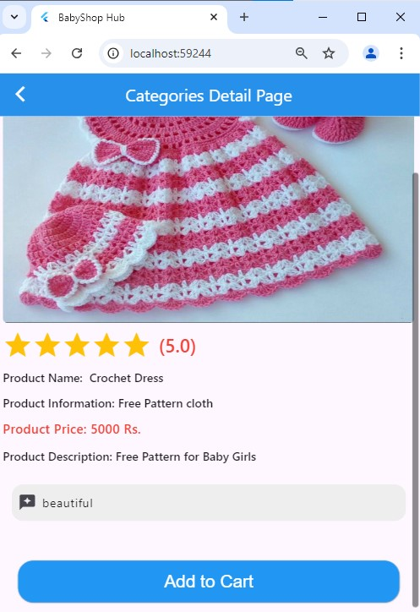

**Product Review Page:**

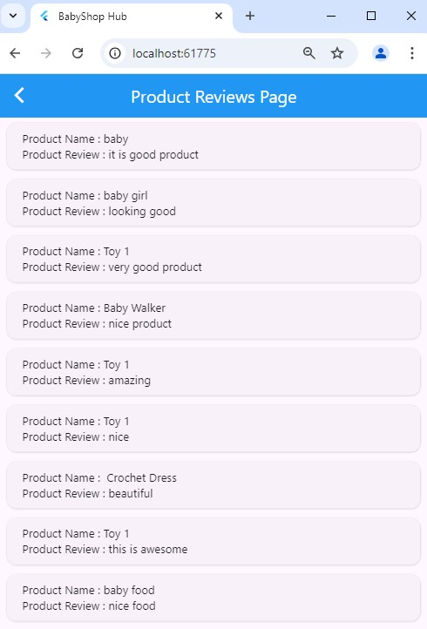

**User Profile:**

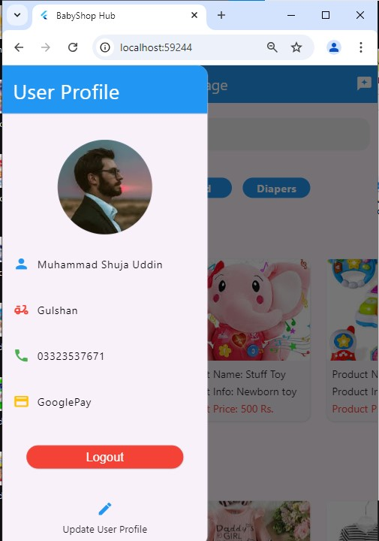

**Update User Profile:**

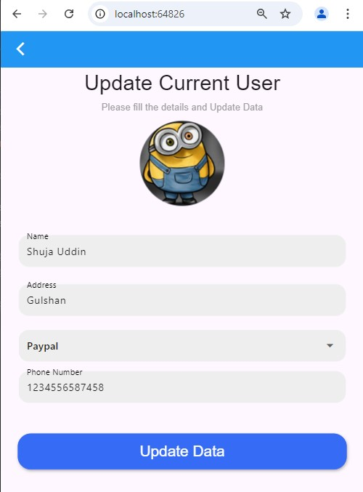

**Payment Categories:**

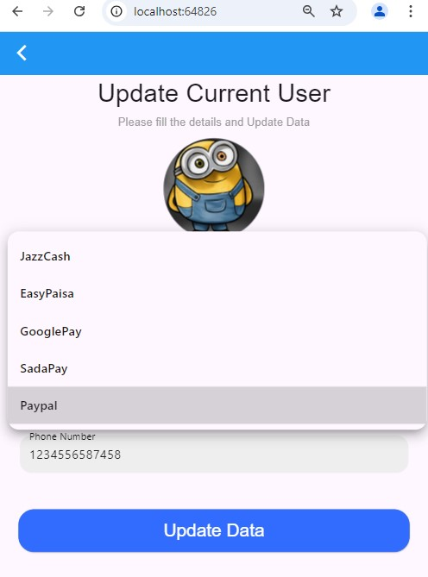

**Checkout Payment:**

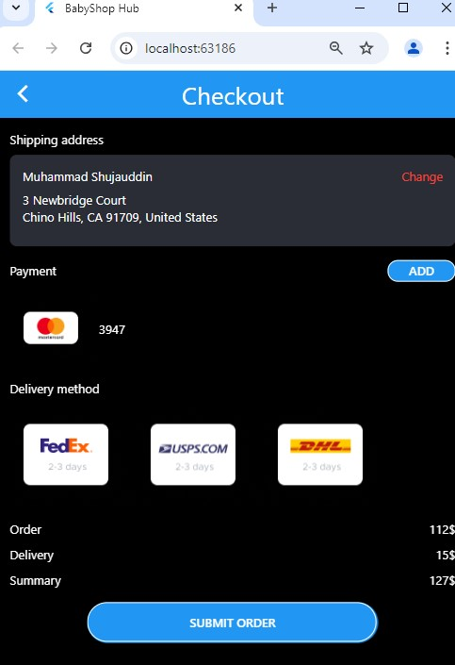

**User Support:**

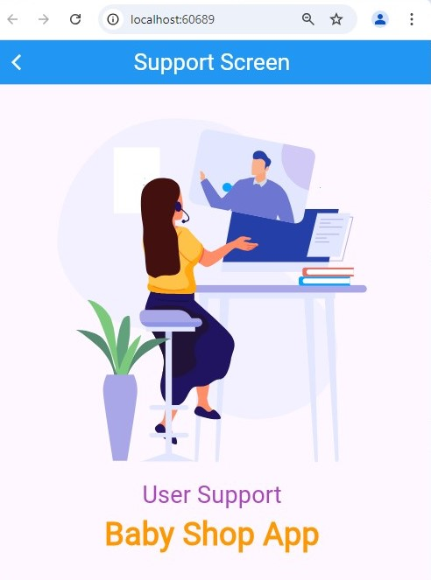

**Add To Cart:**

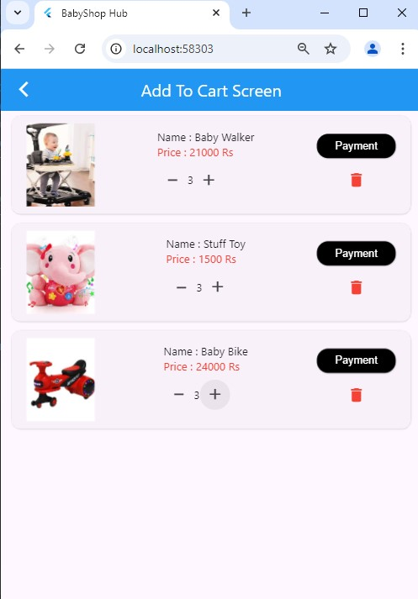

**Order History:**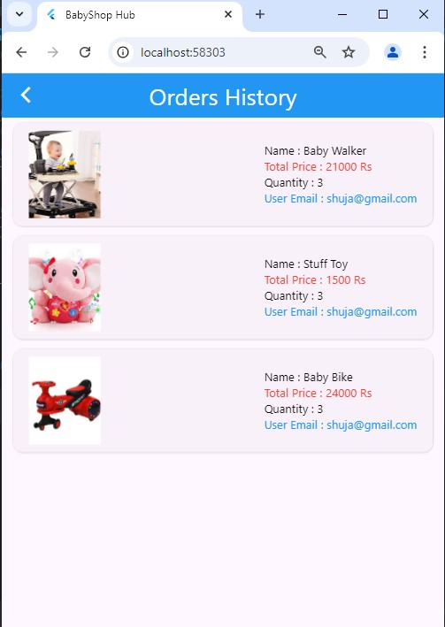

**Add Item:**

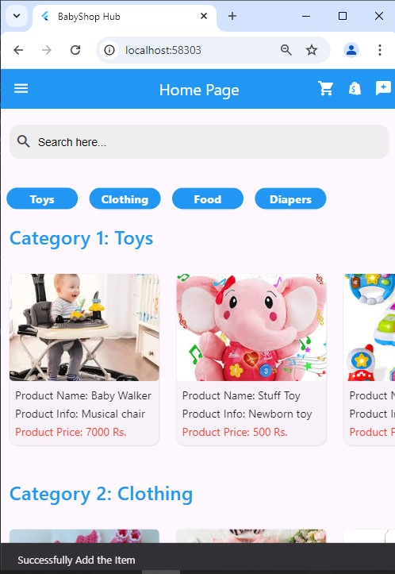

**Submitted Order:**

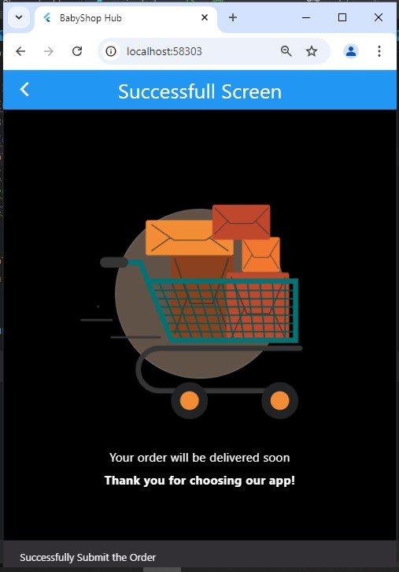

**Admin Page for Users Management:**

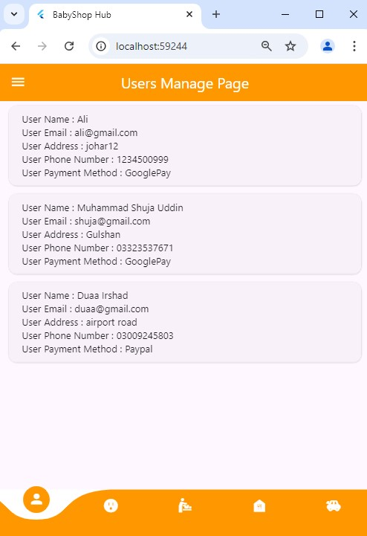

**Categories Manage By Admin:**

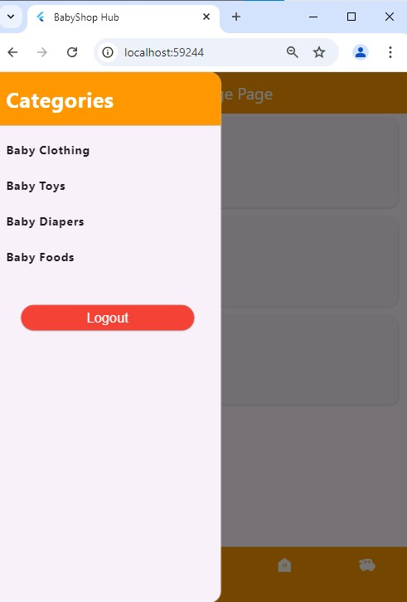

**Adding Products By Admin:**

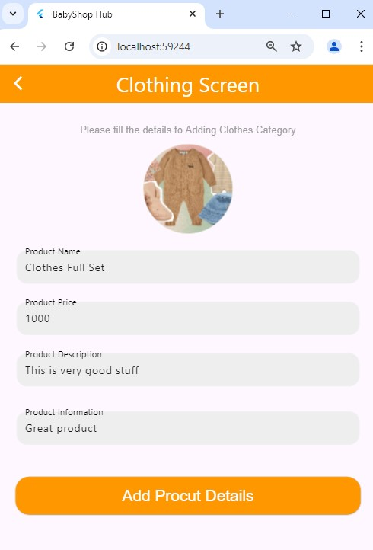

**Toy Fetch Page By Admin:**

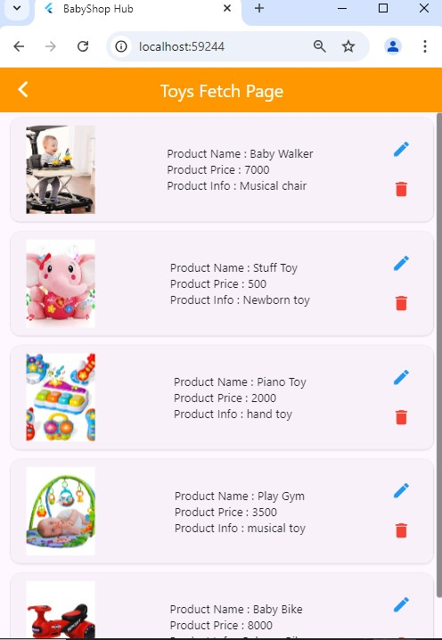

**Food Fetch Page By Admin:**

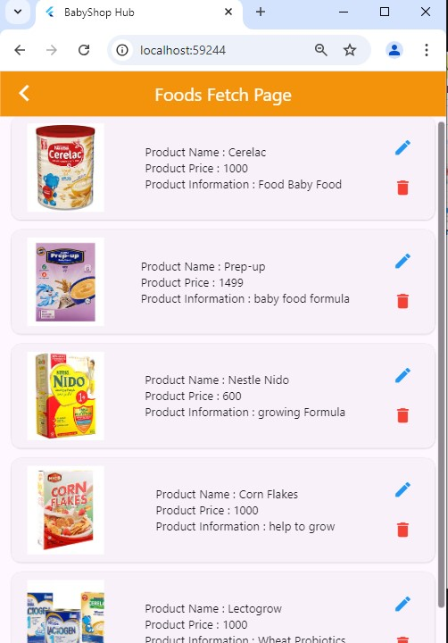

**Diapers Fetch Page By Admin:**

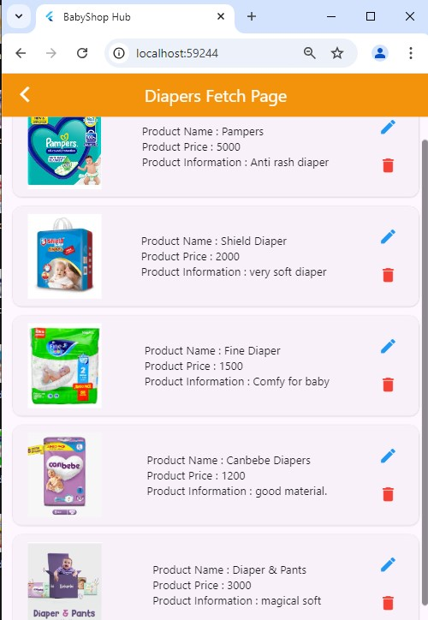

**Clothing Fetch Page By Admin:**

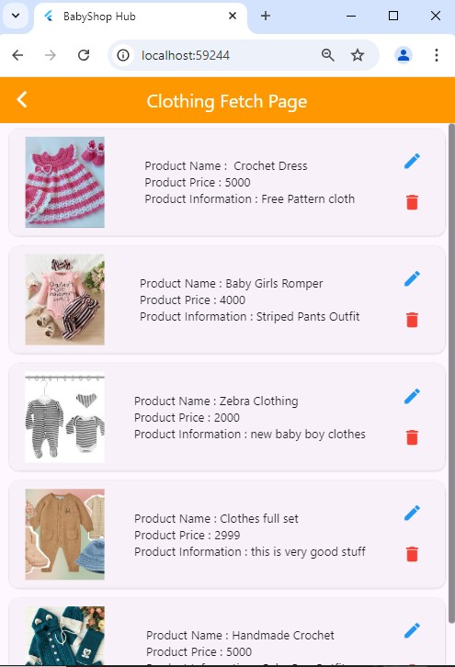

**Update Data By Admin:**

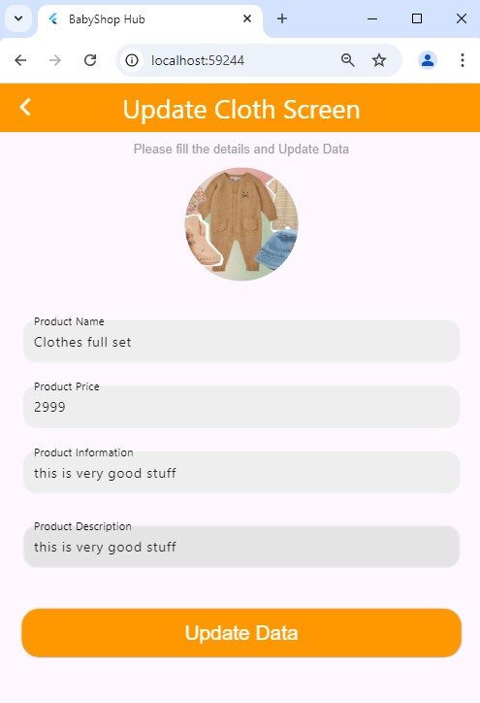

**Admin Order History:**

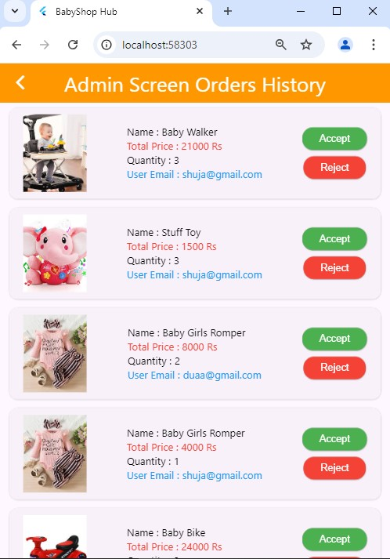

**Fire Base Data-Base:**

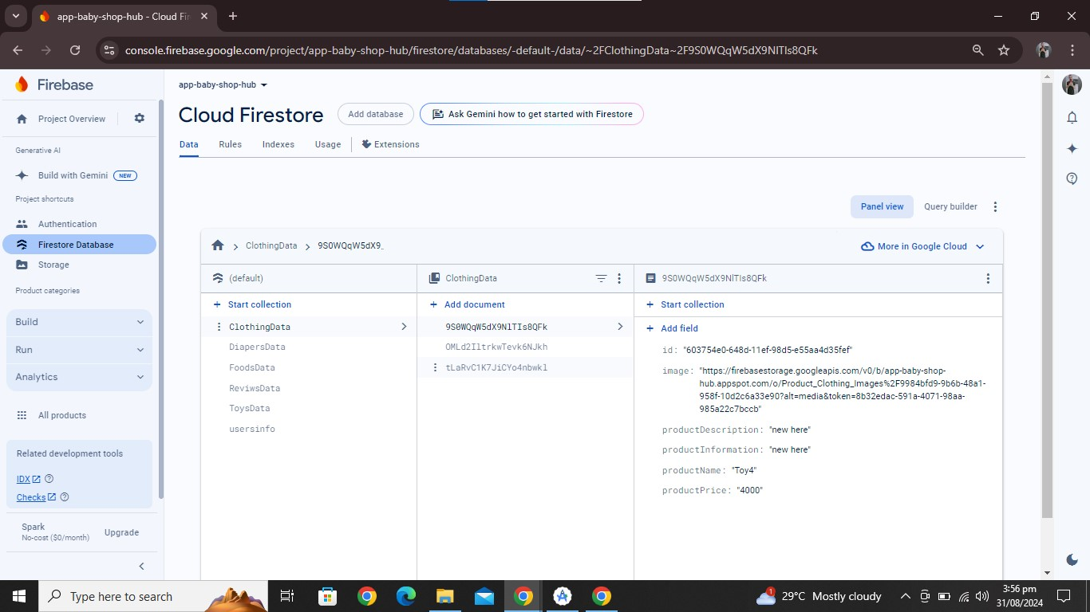

**Project Coding:**



